Logging using SLF4J

Exercise 1: Logging Error Messages and Warning Levels

Task:
Write a Java application that demonstrates logging error messages and warning levelsusing SLF4J.

Step-by-Step Solution:

- Add SLF4J and Logback dependencies to your `pom.xml` file:

<dependency>
<groupId>org.slf4j</groupId>
<artifactId>slf4j-api</artifactId>
<version>1.7.30</version>
</dependency>
<dependency>
<groupId>ch.qos.logback</groupId>
<artifactId>logback-classic</artifactId>
<version>1.2.3</version>
</dependency>

- Create a Java class that uses SLF4J for logging:

import org.slf4j.Logger;
import org.slf4j.LoggerFactory;

public class LoggingExample {
private static final Logger logger = LoggerFactory.getLogger(
LoggingExample.class
);

public static void main(String[] args) {
logger.error("This is an error message");
logger.warn("This is a warning message");
}
}

SOLUTION CHECKLIST

- Dependencies Added to pom.xml
- Maven project refreshed and dependencies downloaded successfully
- Java class LogginExample created under src/main/java/com/cognizant
- SLF4J Logger Initialized:
private static final Logger logger = LoggerFactory.getLogger(
LoggingExample.class
);
- Logging statements added inside main method:

logger.error("This is an error message");
logger.warn("This is a warning message");

- Required imports added:

import org.slf4j.Logger;
import org.slf4j.LoggerFactory;

- Application compiled using:

mvn compile

- Log messages successfully printed in the console with appropriate ERROR and WARN levels

OUTPUT

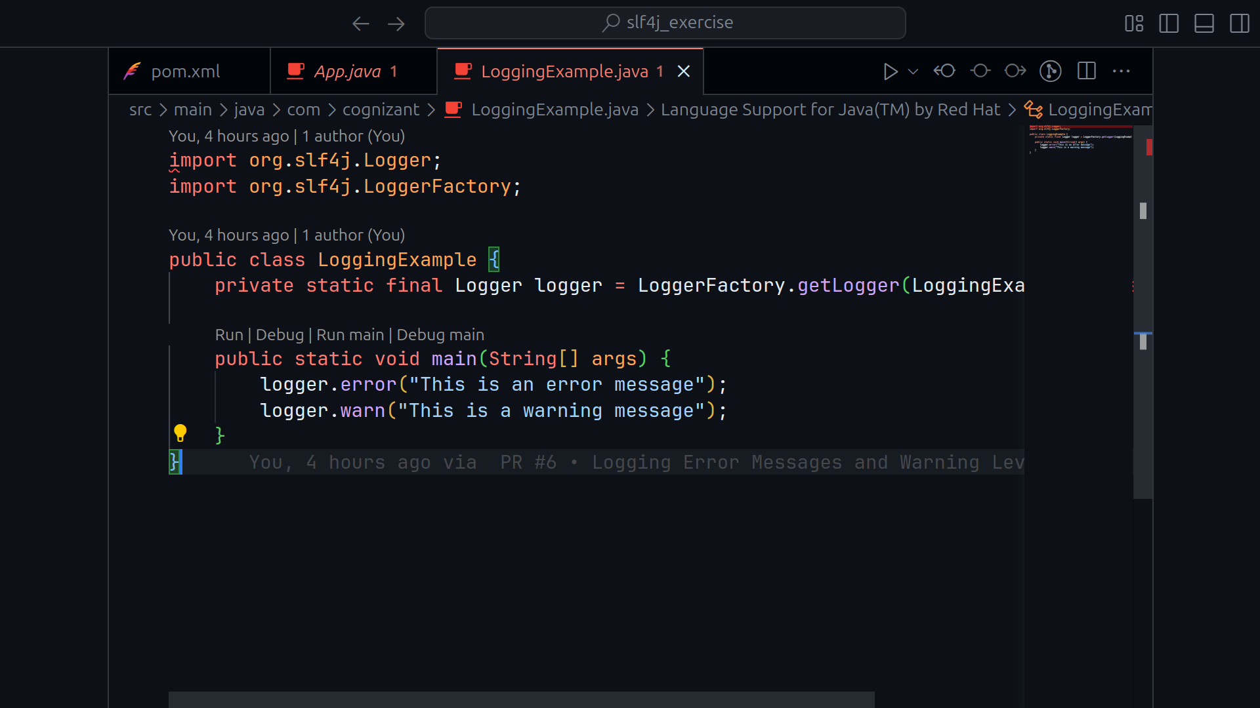

RUNNING OUTPUT

